DOCKER:

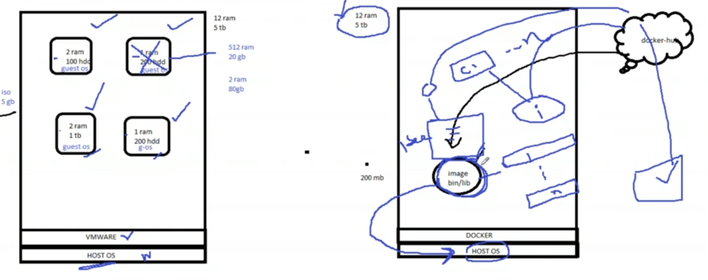

|  |  |
| --- | --- |
| COMMAND | DESCRIPTION |
| #yum install docker | To install docker in linux |
| #docker info | To know full information about docker. Like how many containers in docker, run, stop, paused state also it will show |
| #docker images | To see how many images in docker |
| #docker search imagename | To search any image with name |
| #docker sarch helloworld | To search helloworld image |
| #docker search centos | To see all centos images which are availble |
| #docker image centos | To search about centos image |
| #docker –version | To see the version of installed docker |
| #docker info | By default windos gives all access to docker service, but we have to start service in linux |
| #service docker starts | To start docker service in linux |
| #service docker status | To see docker status in linux |
| #systemctl enable docker | To avoid start and stop service every time. Need to enable in bootable process. Then it will starts the servcie while booting |
| #docker images | To see images of docker |
| #docker pull image_name | To pull a image into docker from local repo or central repo |
| #docker run –itd –p 80:80 imagename | To run a imge with port number and check in browser with publlic ip with port |
| #iptable -F | To enable firewalls |
| #docker ps | To see list of running containers |
| #docker stop container_name/container_ID | To stop a running container in docker |
| #docker pull centos | To pull the centos image in docker |
| #docker run –it centos | To start a container (IT- interactive terminal).  If image is not avible in local repo then it takes from centralrepo of dockerhub |
| #docker run –it imagename | To start container with a image.  When we run this command we will go inside of that container |
| #exit | To comeout from coantainer |
| #docker ps | To display only running containers |
| #docker ps –a | To display all containers like stopped and running containers also |
| #docker run –it centos (it creates new centos) | Based on one image we can create multiple containers |
| Exit means comeout from a container and stops container like a instance. If we run container again it creates new container. So to avoid that issue we have to use **(ctrl pq)**. By this we come out from container but container will be in running state. | |
| #docker attach containerID | To enter into running container |
| #docker start containerID | To enter into stopped container |
| #docker run –itd imagename/imageID  (d- detached mode) | just start and continue without entering inside of container |
| If we want to install perticular image with version then we need to give version number along with name while pulling the image. Otherwise by default it will take latest version | |
| #docker kill containerID/ container_name | It kills imidiately with in fractin of seconds |
| #docker pull centos:6.6 | To get perticular versions of image |
| #docker start containerID/ container_name | We can start killed or stopped containers |
| #docker start container_ID container_ID | We can start two containers at a time |
| #docker stop container_ID/container_name | Before delete the container we need to stop it |
| #docker rm container_ID/ container_name | To delete a container which was in stop stage |
| #docker rm –f containerID/ container_name | To delete a container forcefully even if it is not stop |
| #docker ps –aq | To see only container_ID’s of all containers. |
| #docker rm $(docker ps -aq) | To delete all containers at a time |
| #docker rm cid1 cid2 cid3 | To delete multiple cid’s |
| #docker rmi imageID/imagename | To dalete container along with image |
| #docker rmi centos:7 centos:6 | To delete container along with image &version.  We can do this for multiple |
| #docker image -q | To see only imageID’s |
| #docker ps -l | To display latest container which is starts |
| **#dockr exec –it cid /bin/bash** (once after this command even if we exit from the container, it doesn’t stop) here /bin/bash is default path. If we didn’t mention default path it gives error | Exec-execution mode and enter into container  We can’t enter into jenkins ,nginx…. Directly by using attach command, so we use this command. |
| **#docker run –itd –p 8083:8080 nginx**  (here p represents port. 80 is actual port and 83 is our wished port) | To start image along with port number(search in browser with ip:port no) |
| **#docker exec –it cid(jenkins) /bin/bash** | To enter into jenkins docker container |
| Jenkins passwdord will display when we run container in “lt mode” | When we run with detached mode we have to copy paste the code in terminal and give pwd |
| Lab:  #docker ps –a  #docker run –itd 8086:8080 jenkins  #docker exec –it cid(jenkins) /bin/bash  #cat /var/jenkin for passwd  #exit  #docker ps  #docker stop cid(jenkin)  #docker start cid  #docker ps (check in browser) | We can convert a container (which is havig some data ) as image |
| #docker commit cid(jenkins) | based on container data it creatres image.  To convert a container as image we use “commit”  When we try to push image from docker to docker hub, then repo name in docker hub is must same image name or vice versa |
| #docker image | Check for image |
| #docker tag imageid required_imagename | To pass a name or tag for image & to change name also and if we want to push to hub, img_name must be same as repo |
| #docker tag imgID img_name:tagname | To give tag name along with image name otherwise it will take default name as “latest” |
| Note: repository name in docker hub and image name must be same | Docker.hub.com |
| #docker push imgname | To push the image into docker hub |
| #dockler push devops 2021/Batch50 | To push perticular document into docker repo |
| #docker login | To login into docker hub (we can’t push dorectly into docker hub. Before pushing we need to login into docker hub in terminal) |
| #docker push img_name | Check in docker hub |
| #docker logout | To close credentials in terminal |
| # |  |

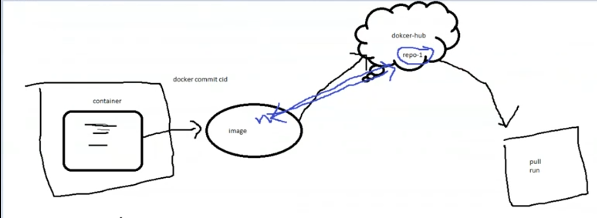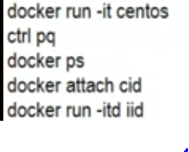

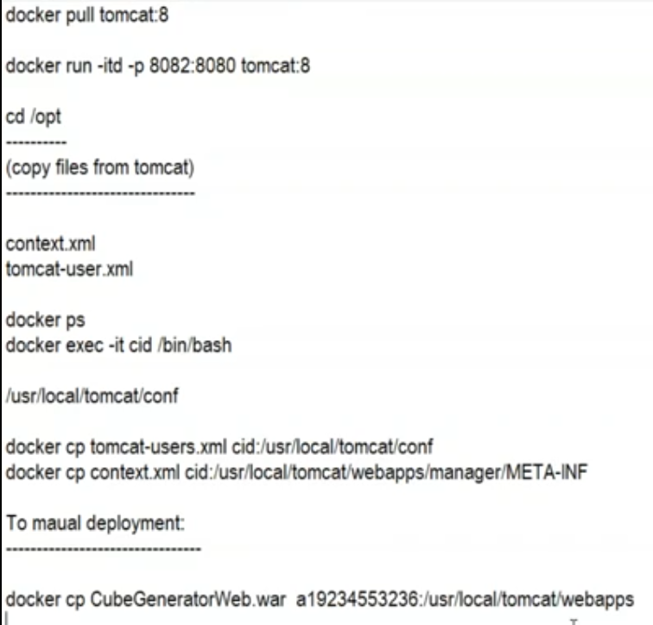

Class3:

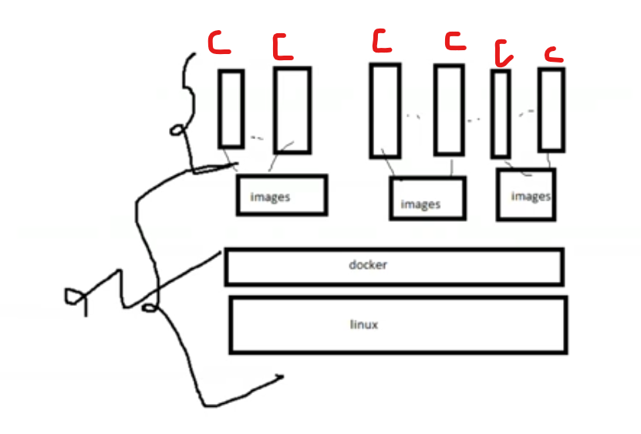

**#docker inspect** 🡪 To know the full information about container like creation date, path and running status …etc.

**#docker restart CID** 🡪 to restart the container

**#docker inspect CID** **| grep IPA(IPaddress)** 🡪to see IP address of container

VOLUMES

**Lab for to share data from host to container**

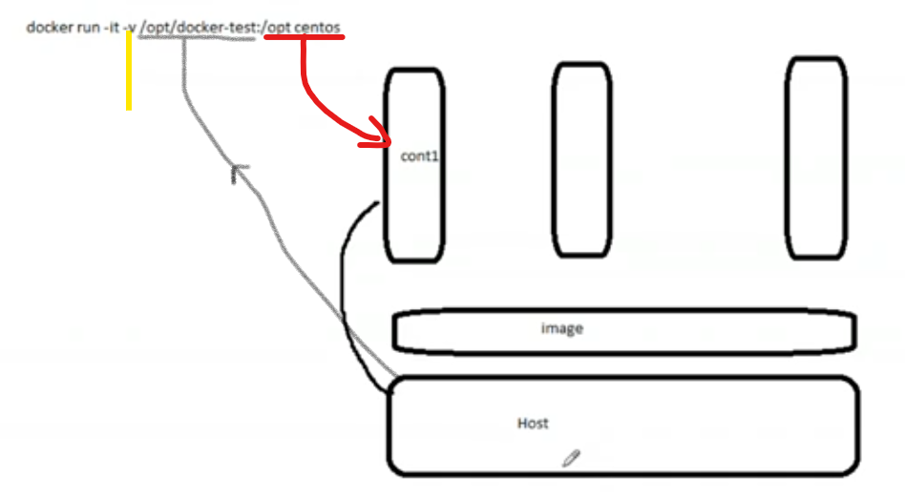

**Here** black line says that path of host OS

Red line sharing path of dir. inside of container

v🡪 volume

|  |  |
| --- | --- |
| #cd /opt | Chose a directory to share data ,linux machine |
| opt]#mkdir docker-test | Make a directory to share data from host to dir |
| opt]#cd docker-test | Move into inside of dir |
| test]#touch file{1..10} #mkdir dir{1..5} #ls | Make sample data for check |
| #pwd | Let’s check where we are |
| #docker run –it –v /opt/docker-test:/opt container_shared | To share data from HOST OS to Container & it creates new container |
| #docker run –it –v /opt/docker-test:/opt/ shared centos |  |
| cid]# cd /opt | cid opt]# ls |
| cid opt]# cd shared | cid shared]#ls ctrl+pq (to comeout) |
| Docker-test]#docker exec –it cid /bin/bash |  |
| cid]#cd /opt/sahred | cid]#ls |
|  |  |

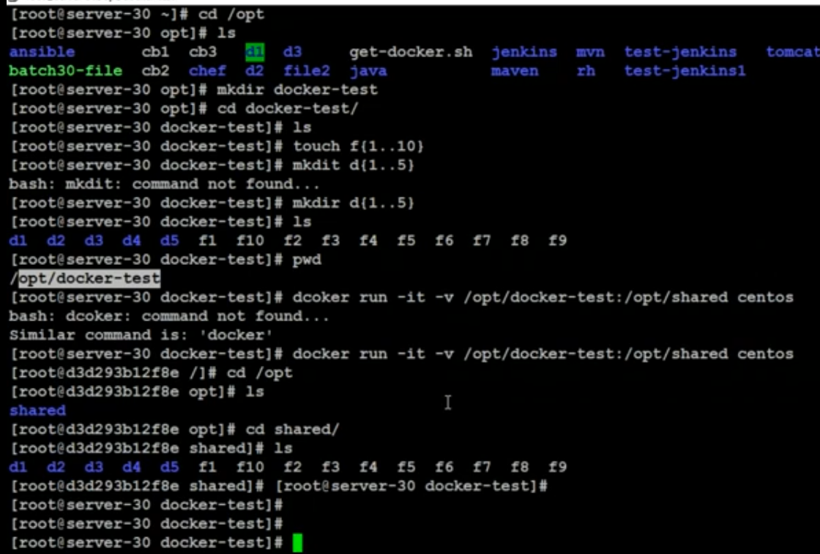

To share data container to container



    
    
    

